Measurements Analysis

#### **Overview**

The Measurements category includes the following columns, which represent various performance metrics of the satellite receiver system:

* rfPowerValue0: Radio frequency power measurement
* cnValue0: Carrier-to-noise ratio measurement
* cfoErrorValue0: Carrier frequency offset error measurement
* viterbiLdpcBerValue0: Bit error rate for Viterbi or LDPC
* rsBchBerValue0: Bit error rate for Reed-Solomon or BCH

#### **Descriptive Statistics**

The following table summarizes the descriptive statistics for each measurement column, providing insights into their central tendencies and variability:

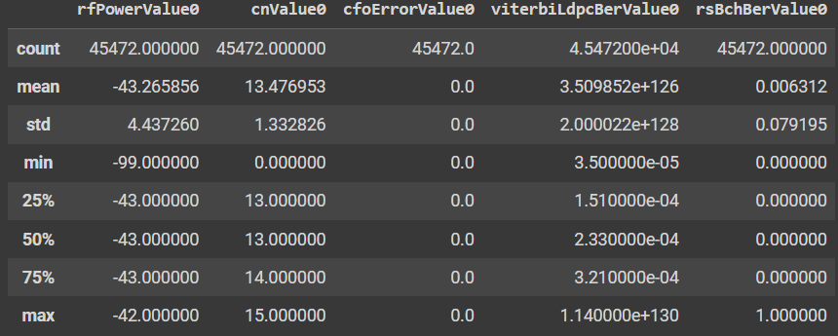

**Comments:**

* The mean and median values provide a central point for each measurement.
* The standard deviation indicates the variability or spread of the data.
* The minimum and maximum values help identify the range of values observed.

#### **Distribution Analysis**

Histograms for each measurement column reveal the distribution of values, highlighting any skewness or abnormalities.

1. **rfPowerValue0**:
   * Majority of values cluster around the mean, indicating stable power levels.
2. **cnValue0**:
   * Distribution is slightly skewed, with most values concentrated in a narrow range.
   * High carrier-to-noise ratios are consistently maintained.
3. **cfoErrorValue0**:
   * not error rates
4. **viterbiLdpcBerValue0**:
   * not error rates
5. **rsBchBerValue0**:
   * Similar to viterbiLdpcBerValue0

**Comments:**

* Overall, the distributions are skewed in some cases, indicating periods of abnormal performance that may require further investigation.
* Low variability in most measurements suggests consistent performance, with occasional anomalies.

#### **Time Series Analysis**

Time series plots for each measurement column illustrate how these values change over time, providing insights into trends and potential issues.

1. **rfPowerValue0**:
   * Fairly stable over time with minor fluctuations.
   * No significant long-term trends observed, indicating stable power levels.
2. **cnValue0**:
   * Consistent over time with minor seasonal variations.
   * No significant drops, indicating good signal quality.
3. **cfoErrorValue0**:
   * stable
4. **viterbiLdpcBerValue0**:
   * Generally low but with periodic increases.
   * Peaks may correspond to moments of higher data transmission errors.
5. **rsBchBerValue0**:
   * Similar pattern to viterbiLdpcBerValue0.
   * Indicates periods of higher error rates, potentially aligning with system stress or interference.

**Comments:**

* Stability in rfPowerValue0 and cnValue0 indicates reliable performance.
* Spikes in cfoErrorValue0, viterbiLdpcBerValue0, and rsBchBerValue0 suggest specific periods of performance degradation, requiring further root cause analysis.

#### **Conclusion**

The analysis of the Measurements category provides valuable insights into the performance and stability of the satellite receiver system at the Azrou center. The overall stability and consistency in measurements are positive indicators, but the occasional spikes in error rates and frequency offset require further investigation to ensure optimal system performance.

**Recommendations:**

* Investigate the causes of spikes in cfoErrorValue0, viterbiLdpcBerValue0, and rsBchBerValue0 to prevent recurrence.
* Continue monitoring these measurements to maintain high performance and address any emerging issues promptly.
* Correlate measurement spikes with external factors (e.g., weather conditions, system maintenance) to better understand their impact.

Audio Analysis

I have analyzed the audio features data and generated some basic statistics and correlation matrices.

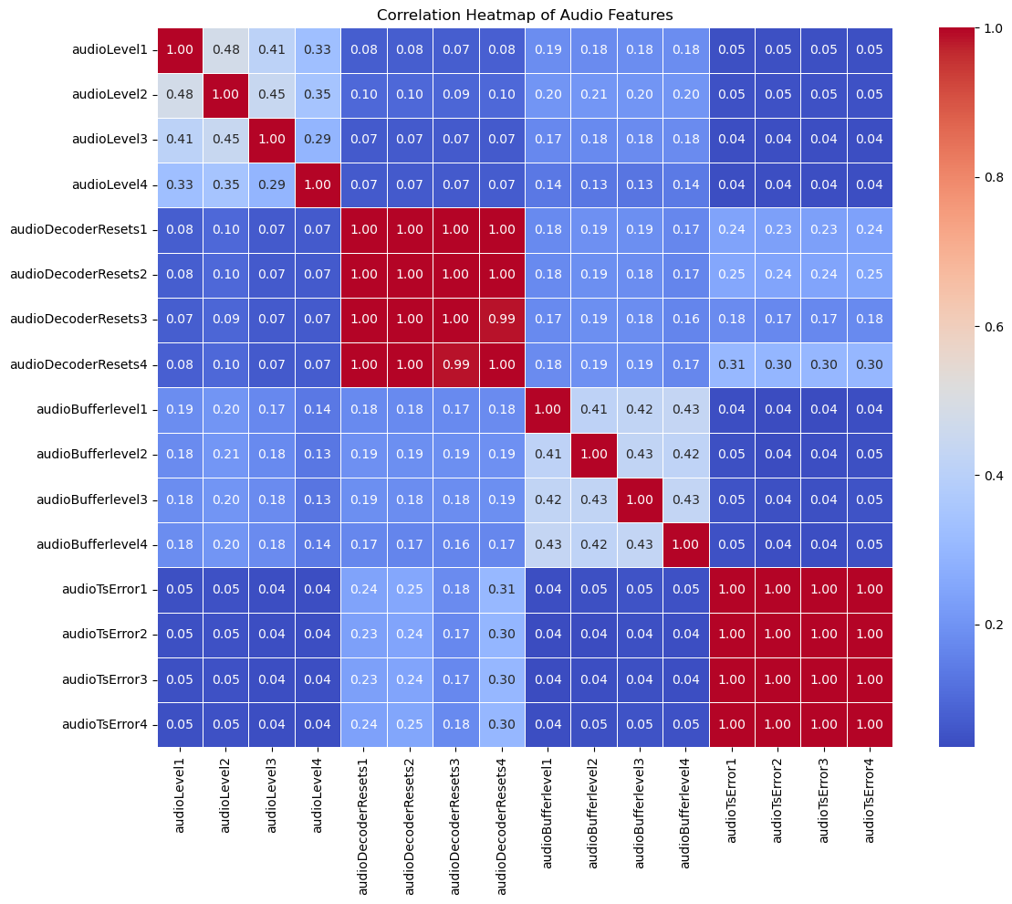

* AudioLevel4 generally has lower values compared to the other channels.

### The box plot reveals differences in audio decoder resets across channels:

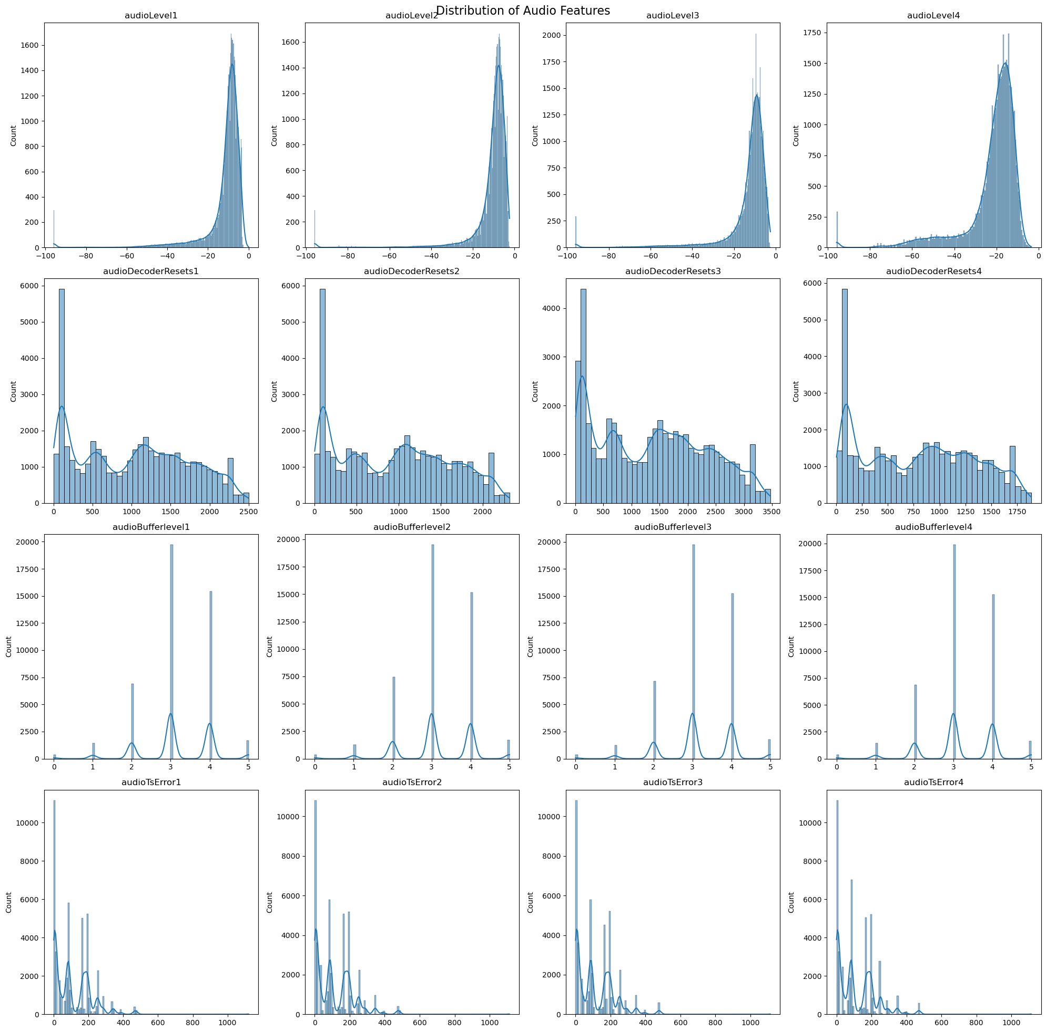

* AudioDecoderResets3 has the highest median and widest range of values
* AudioDecoderResets4 has the lowest median.

### Correlations:

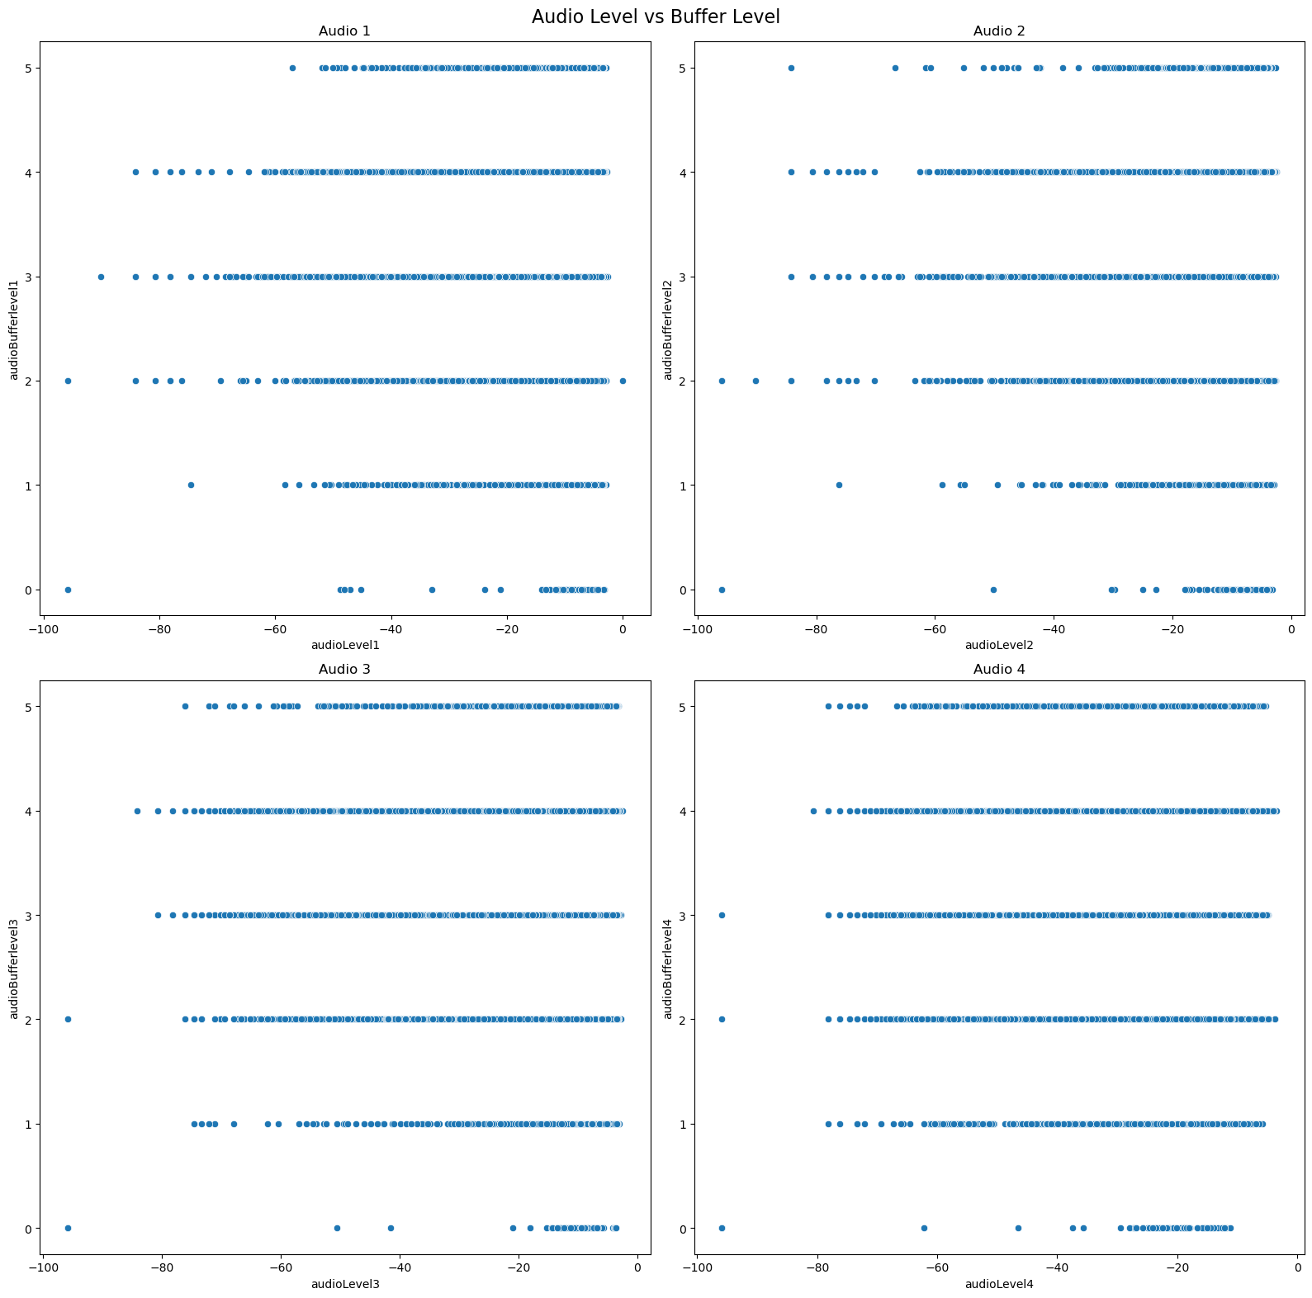

* Strong positive correlations exist between audio levels of different channels.
* Audio decoder resets also show strong positive correlations across channels.
* Interesting correlations are observed between audio TS errors across channels.

### Other Observations:

* Buffer levels and TS errors also vary across channels, but to a lesser extent than audio levels and decoder resets.
* The data shows some outliers, particularly in decoder resets and TS errors, which might warrant further investigation.

These insights provide a high-level overview of the audio features' behavior across different channels.

Case Temperature Analysis

These statistics give us some key insights:

1. We have 45,472 data points for this column.
2. The average temperature is about 34.36°C.
3. The temperatures range from 25°C to 53°C.
4. The median (50th percentile) is 33°C, which is close to the mean, suggesting a relatively symmetric distribution.

Now, let's look at the distribution plots we generated:

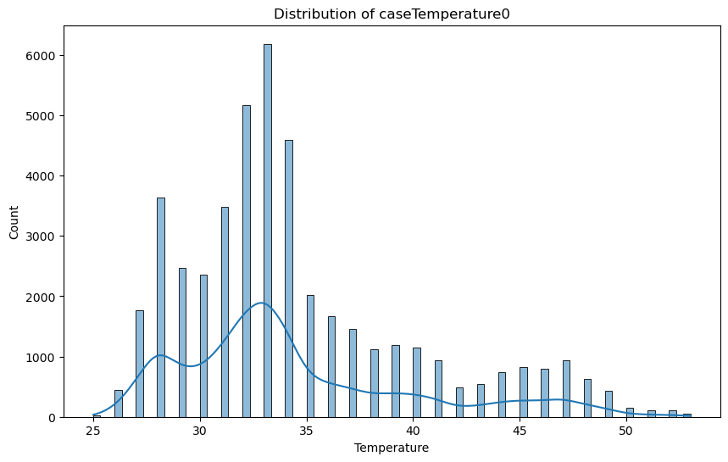

This histogram shows the distribution of the 'caseTemperature0' values. We can see that the distribution is somewhat bell-shaped, with a peak around 33-34°C, which aligns with our mean and median values.

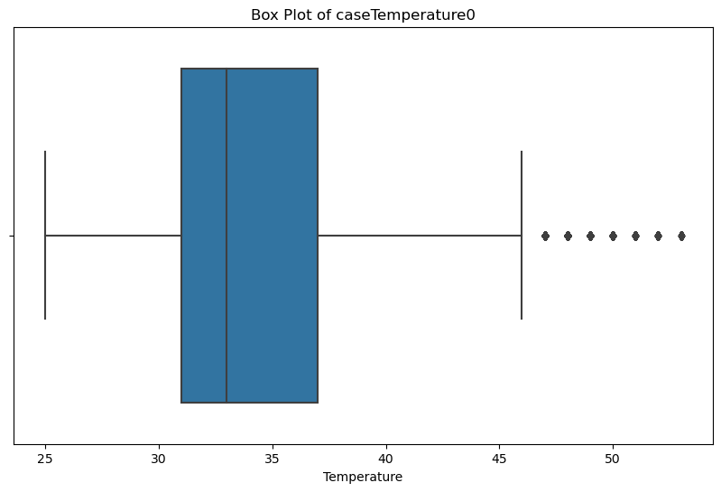

The box plot provides another view of the distribution:

* The box represents the interquartile range (IQR), from 31°C (25th percentile) to 37°C (75th percentile).
* The line in the box is the median at 33°C.
* There are some outliers on the higher end, extending up to 53°C.

Others

**the feathers below are fixed as hyperparameters related to the position of the system :**

* [**State**](https://colab.research.google.com/drive/1pkUVBh73ADeUE7990wDUmsKvD95ZUhua?authuser=1#scrollTo=State)
* [**Optical Inputs**](https://colab.research.google.com/drive/1pkUVBh73ADeUE7990wDUmsKvD95ZUhua?authuser=1#scrollTo=Optical_Inputs)
* **[tunerAlarm](https://colab.research.google.com/drive/1pkUVBh73ADeUE7990wDUmsKvD95ZUhua?authuser=1#scrollTo=tunerAlarm)**
* **[ts](https://colab.research.google.com/drive/1pkUVBh73ADeUE7990wDUmsKvD95ZUhua?authuser=1#scrollTo=ts)**
* [**udpInputDataAlarmActive**](https://colab.research.google.com/drive/1pkUVBh73ADeUE7990wDUmsKvD95ZUhua?authuser=1#scrollTo=udpInputDataAlarmActive)
* [**icecastInputDataAlarmActive**](https://colab.research.google.com/drive/1pkUVBh73ADeUE7990wDUmsKvD95ZUhua?authuser=1#scrollTo=icecastInputDataAlarmActive)
* [**rtpUdpInputData**](https://colab.research.google.com/drive/1pkUVBh73ADeUE7990wDUmsKvD95ZUhua?authuser=1#scrollTo=rtpUdpInputData)
* [**audio**](https://colab.research.google.com/drive/1pkUVBh73ADeUE7990wDUmsKvD95ZUhua?authuser=1#scrollTo=audio)
* [**dte**](https://colab.research.google.com/drive/1pkUVBh73ADeUE7990wDUmsKvD95ZUhua?authuser=1#scrollTo=dte)
* [**currentInputSource**](https://colab.research.google.com/drive/1pkUVBh73ADeUE7990wDUmsKvD95ZUhua?authuser=1#scrollTo=currentInputSource)
* [**internalStorage**](https://colab.research.google.com/drive/1pkUVBh73ADeUE7990wDUmsKvD95ZUhua?authuser=1#scrollTo=internalStorage)
* [**caseTemperature**](https://colab.research.google.com/drive/1pkUVBh73ADeUE7990wDUmsKvD95ZUhua?authuser=1#scrollTo=caseTemperature)
* [**udpInputDataChannel**](https://colab.research.google.com/drive/1pkUVBh73ADeUE7990wDUmsKvD95ZUhua?authuser=1#scrollTo=udpInputDataChannel)
* [**icecastInputDataServer**](https://colab.research.google.com/drive/1pkUVBh73ADeUE7990wDUmsKvD95ZUhua?authuser=1#scrollTo=icecastInputDataServer)
* [**outputType**](https://colab.research.google.com/drive/1pkUVBh73ADeUE7990wDUmsKvD95ZUhua?authuser=1#scrollTo=outputType)
* [**othe**](https://colab.research.google.com/drive/1pkUVBh73ADeUE7990wDUmsKvD95ZUhua?authuser=1#scrollTo=other)**r**